Github: Shahidhasib586
Linkedin: Shahid Ahamed Hasib

How to calibrate your BlurRov sensors and thrusters

Open QgroundController:

Go to vehicle setup
for sensor calibration go to sensors and select your sensor and follow the instructions.

For thruster calibration follow this:

- Go vehicle setup in Qgcontroll
- select motors
- see your thruster configuration

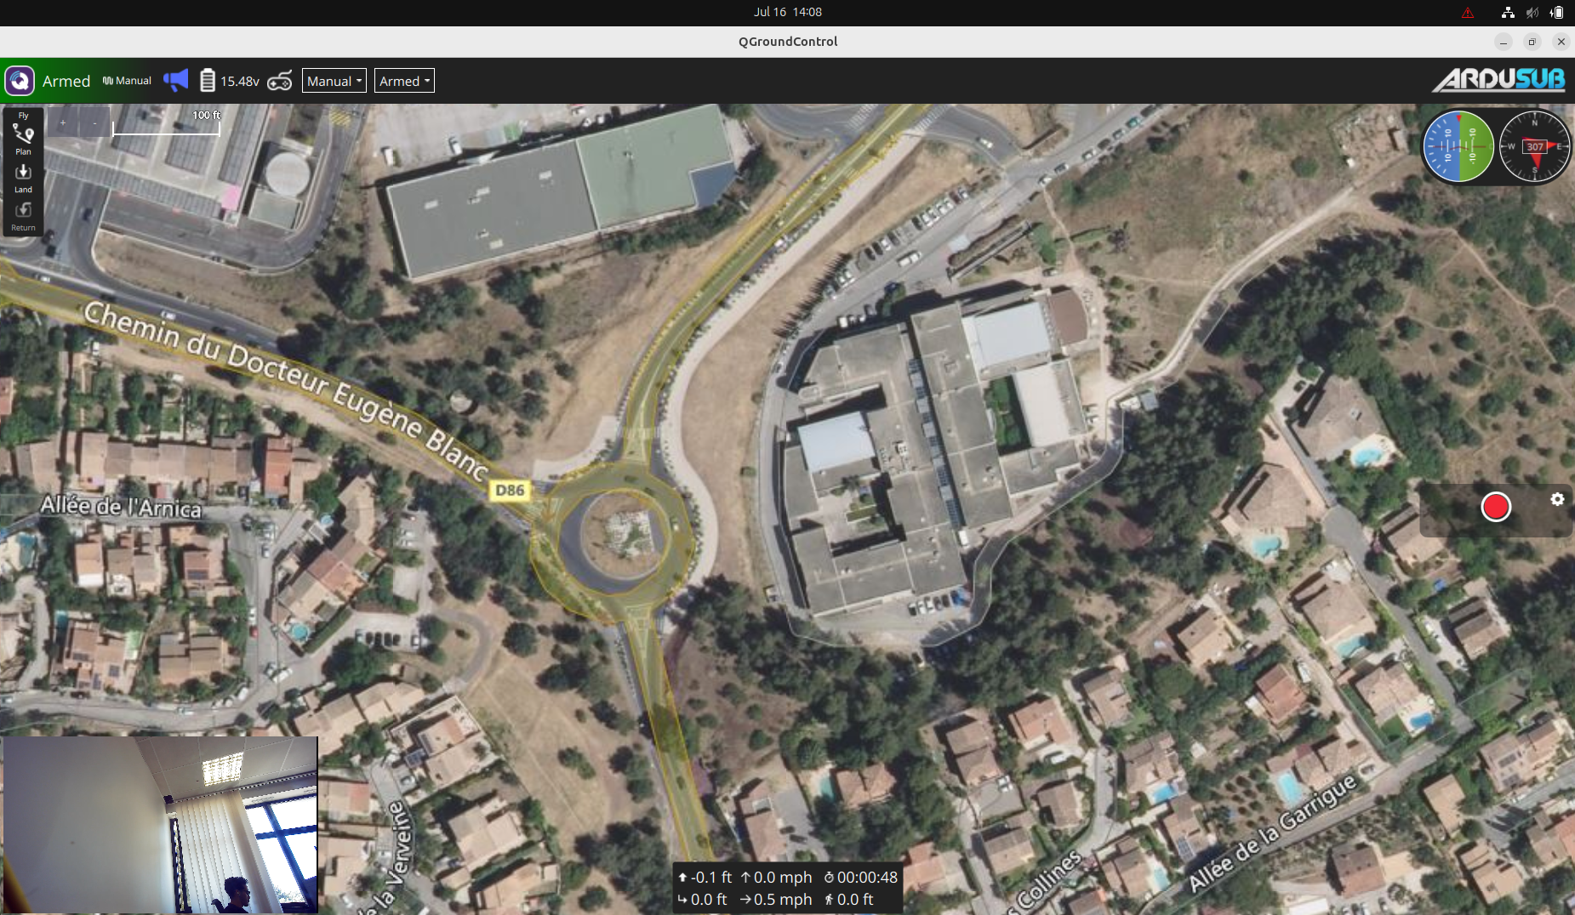
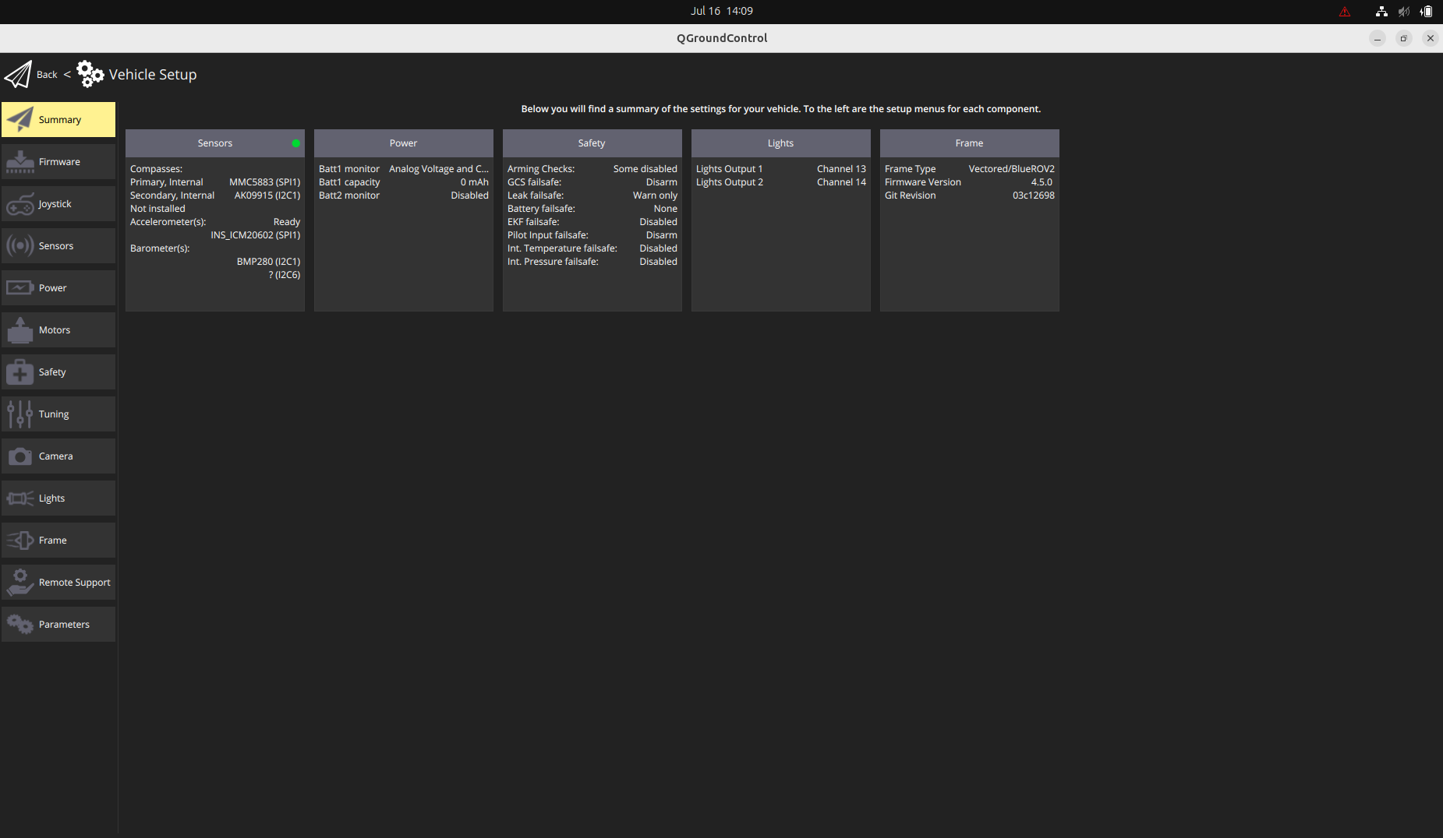

wait for 10 seconds and slide co change the thruster configuration, reverse the thruster rotation according to the thruster configuration for this blueROV the thrusters 1, 2, and 5 should be reversed

